Modules & Packages (5 Questions)
1. You are building a large application with authentication, database, and logging features. How would you structure this using packages and sub-packages? Explain the role of __init__.py.
For a large application, code should be grouped by responsibility, not by file size.
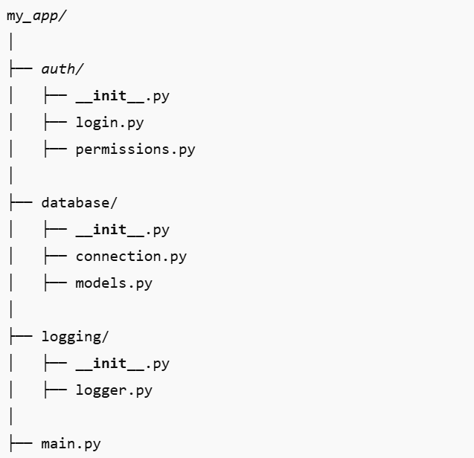
- Each folder is a package
- Each package groups related functionality
- Sub-packages help keep code modular and maintainable
Role of __init__.py:
- Marks a directory as a Python package
- Controls what gets imported when the package is imported
- Can initialize package-level variables or expose selected functions using __all__

2. A script works fine when run directly but fails with ModuleNotFoundError when imported from another folder. What could be the reasons and how would you fix it?
This usually happens because Python cannot find the module path.
Common reasons:
- The module is not in the same directory
- The parent directory is not in PYTHONPATH
- Relative imports are used incorrectly
- The script relies on the current working directory
Fixes:
- Use absolute imports
- Run the program from the project root
- Add the project directory to PYTHONPATH
- Use relative imports inside packages:
3. You want to share common utility functions across multiple projects without copying code. How would you create and use a custom module for this?
Create a custom reusable module or package.
Steps:
- Create a folder:
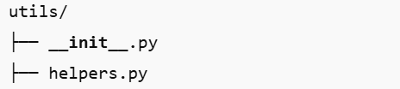
- Write common functions in helpers.py
- Use it by:
- Copying the folder into projects or
- Installing it as a local package using pip install -e .
This avoids duplication and keeps logic consistent.

4. Two different modules have functions with the same name. How would you import them to avoid name conflicts?
Using module names:
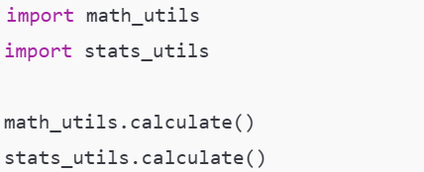
Using aliases:

5. Your project has heavy modules that slow down startup time. How can lazy importing help, and when would you use it?
Lazy importing means importing a module only when it is needed, not at startup.
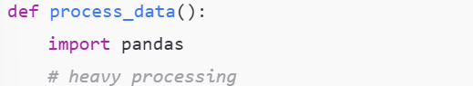
Why it helps:
- Reduces initial load time
- Saves memory
- Improves performance for rarely used features
When to use it:
- Heavy libraries (machine learning, data analysis)
- Optional features
- Command-based or plugin-style systems
When not to use it:
- Core dependencies needed everywhere
- Code where readability is more important than startup speed

Generators (5 Questions)
1. You need to process a 10GB log file line by line without loading it fully into memory. Why are generators a better choice than lists?
Why generators are better than lists
- A list loads the entire file into memory at once, which is impractical for very large files.
- A generator produces one line at a time, only when requested.
Why this matters:
- Constant memory usage (O(1))
- Faster startup time
- Safer for large or unknown file sizes
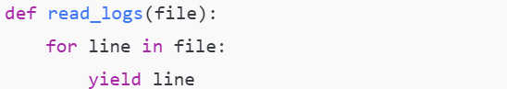
This approach scales regardless of file size.

2. You are generating an infinite sequence of timestamps for a monitoring system. How would you safely implement this using a generator?
An infinite generator must:
- Yield values incrementally
- Avoid memory growth
- Allow controlled consumption
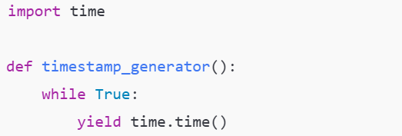
Safety measures:
- Consume it using limits (next(), counters, or itertools.islice)
- Stop externally when conditions are met
This ensures the generator runs indefinitely without exhausting memory.

3. A generator function has multiple yield statements inside loops and conditionals. How does Python remember where to resume execution?
Python remembers the generator’s state using a generator frame object, which stores:
- Current instruction pointer
- Local variables
- Loop counters
- Conditional states
When yield is executed:
- Function execution is paused
- State is saved
- Control returns to the caller
When resumed with next():
- Execution continues exactly after the last yield
This is why generators work correctly across loops and conditionals.

4. You want to stop a generator midway based on a condition. How can this be done, and what happens internally?
A generator can stop in three ways:
i. Using return:
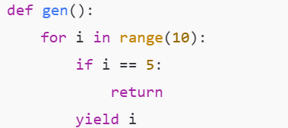
ii. Reaching the end of the function
iii. Raising StopIteration (implicitly)
Internally:
- Python raises a StopIteration exception
- The generator becomes exhausted
- Further calls to next() raise StopIteration
Once stopped, a generator cannot be restarted.

5. Compare a generator expression and a list comprehension in a real-time data streaming scenario. Which one would you choose and why?
List comprehension:
- Loads all data into memory
- Not suitable for streams or infinite data
Generator expression:
- Produces values on demand
- Minimal memory usage
- Ideal for real-time processing
Best choice for streaming: Generator expression
Reason:
- Handles continuous or unbounded data
- Works naturally with pipelines
- Prevents memory overload

File Handling (5 Questions)
1. You are writing logs to a file and want to ensure data is saved even if the program crashes. Which file mode and techniques would you use?
File mode:
- Use append mode ("a" or "a+") so existing logs are not overwritten.
Techniques to ensure data safety:
- Flush buffers regularly:
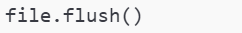
- Use line buffering or unbuffered writes where appropriate
- Prefer Python’s built-in logging module, which handles buffering, flushing, and file rotation safely
Why this works:
- Append mode prevents data loss
- Flushing ensures data is written to disk, not stuck in memory buffers

2. A file is being read by multiple processes at the same time. What issues can occur and how would you prevent data corruption?
Possible issues:
- Partial reads if the file is being written simultaneously
- Inconsistent or stale data
- Race conditions if reads and writes overlap
Prevention methods:
- Use file locks (shared locks for reading, exclusive locks for writing)
- Separate read and write responsibilities
- Use OS-level locking mechanisms (for example, advisory locks)
Key idea:
Reading alone is usually safe, but reading while writing is where corruption or inconsistency can occur.

3. You need to read a CSV file, clean the data, and write the output to another file. How would you handle this efficiently?
Best practices:
- Read the file line by line, not all at once
- Use the csv module to handle parsing correctly
- Clean each row as it is read
- Write cleaned data incrementally
Conceptual flow:
- Open input file
- Iterate row by row
- Clean and validate data
- Write output immediately
Why this is efficient:
- Low memory usage
- Works for large CSV files
- Easier error handling per row

4. A file contains sensitive data. How would you ensure it is properly closed and not left open accidentally?
Use a context manager (with statement):
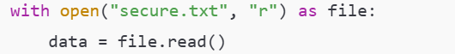
Why this is important:
- File is closed automatically
- Works even if an exception occurs
- Prevents file descriptor leaks
This is the safest and most recommended method.

5. While reading a large file, your program suddenly raises an exception. How can you make sure the file is still closed properly?
Using with (preferred):
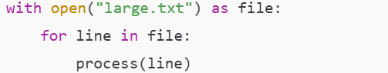
Using try–finally:
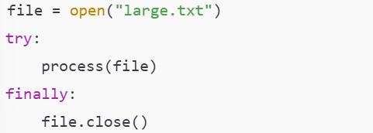
What happens internally:
- Cleanup code runs even when an exception is raised
- The file handle is released back to the operating system

Decorators (5 Questions)
1. You want to log the execution time of multiple functions without modifying their code. How would decorators help here?
Decorators allow you to wrap existing functions with additional behavior without changing their internal logic.
How this helps:
- The timing logic is written once
- It can be applied to many functions
- Core function code remains untouched
Conceptual flow:
- Decorator records start time
- Calls the original function
- Records end time
- Logs the difference
This follows the separation of concerns principle.

2. A function should only run if the user is authenticated. How would you enforce this using a decorator?
An authentication decorator checks user credentials before the function runs.
How it works:
- Decorator intercepts the function call
- Verifies authentication status
- Either allows execution or blocks it
Result:
- Unauthorized users never reach the function logic
- Security is centralized and consistent
- Easier to maintain than repeating checks inside functions
3. You are using multiple decorators on a single function. In what order are they executed, and why does this matter?
Decorators are applied from bottom to top, but executed from top to bottom.
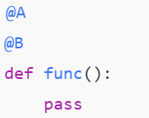
Equivalent to:
- The outer decorator (A) controls the final behavior
- Changing order can change logic, performance, or security
- Critical for decorators like authentication, caching, and logging

4. A decorator breaks a function’s original name and docstring. How would you fix this issue?
When a decorator wraps a function, metadata like:
- __name__
- __doc__
gets replaced by the wrapper’s metadata.
Fix:
Use functools.wraps inside the decorator.
Why this works:
- Copies metadata from the original function
- Keeps debugging, documentation, and introspection accurate

5. You want a decorator that accepts arguments (for example, a retry count). How is this different from a normal decorator?
Normal decorator:
- Takes only a function as input
Decorator with arguments:
- Takes arguments first
- Returns a decorator
- That decorator then returns a wrapper
Conceptual structure:
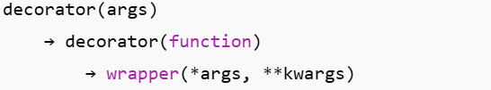
Why this is needed:
- Allows configurable behavior
- Example use cases: retry count, timeout limit, role-based access

